

Rapid Build
Single Sign-on setup

Prepared by: Rapid Solutions and Consulting LLC
Last Updated: November 30, 2016

Table of Contents
1. Introduction 3
2. SSO setup in BUILD 4

1. Introduction

RapidBuild (Build) is a tool part of the Rapid client suite used to automate the setup of Oracle Applications configurations using the Oracle Forms playback and HTML technology to inject configurations.

The Oracle EBS server can be configured to redirect any requests to login to a custom login page. This is known as Single Sign-on (SSO). In large organizations, users often have a large number of userids for a variety of network-based resources such as corporate websites and custom applications. As the number of available resources grow, users and security administrators are faced with the increasingly-difficult challenge of managing a proliferation of userids and passwords across different systems.
Enterprise identity management solutions allow security administrators to define a user in a single location such as an Lightweight Directory Access Protocol (LDAP) directory, and share that common user definition throughout multiple parts of their enterprise.
In its default configuration, Oracle E-Business Suite Release 12 allows registered users to log in using credentials stored directly in the E-Business Suite. In this default configuration, E-Business Suite system administrators are responsible for maintaining the local repository of registered E-Business Suite users.
Instead of performing authentication natively, via the local E-Business Suite FND_USER table, the E-Business Suite Release 12 now delegates this functionality to the Oracle Single Sign-On server. In this configuration, Oracle E-Business Suite Release 12 can direct unauthenticated users to an Oracle Single Sign-On server for identity verification, and securely accept identities vouched for by the Single Sign-On mechanism.
This document describes the special setup and behavior of RapidBuild necessary to support SSO EBS instances.

2. SSO setup in BUILD

The standard portal login page to EBS in R12 is as below:

But in a SSO configuration, all Login requests are redirected to a custom portal page - Example:

In order to enable SSO in BUILD, you need to edit the “Single Sign On” form located in the RapidBuild's second screen.

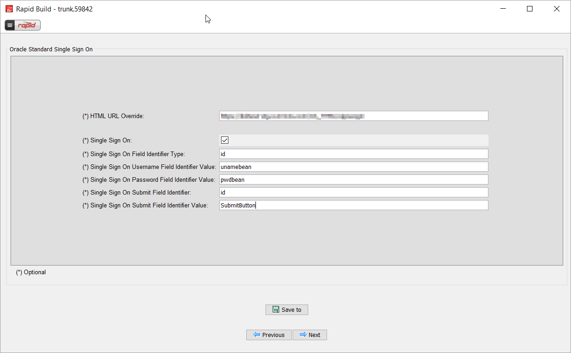
Enter the following values in the form:

Single Sign On : <checked>
Single Sign On Field Identifier Type : NAME
Single Sign On Username Field Identifier Value : ssousername
Single Sign On Password Field Identifier Value : password
Single Sign On Submit Button Identifier Type : ID
Single Sign On Submit Button Identifier Value : OK

You need to right-click on the HTML SSO login page and find out for the user name, password input fields and submit button what are their HTML inner identifiers. Example if the HTML source code shows the following for your SSO page:

User name: <input name="ssoLogin">
Password: <input name="ssoPwd">
Login: <input type="submit" value="Submit">
then change the form values to:

Single Sign On Field Identifier Type : name
Single Sign On Username Field Identifier Value : ssoLogin
Single Sign On Password Field Identifier Value : ssoPwd
Single Sign On Submit Button Identifier Type : value
Single Sign On Submit Button Identifier Value : Submit
Note: by default BUILD will use the default EBS R12 login page URL which will automatically redirect to the SSO page. However in some customer cases, the EBS default login does not redirect to the SSO page, in this case you will need to force BUILD to use the SSO login page directly by changing the form value as is specified below:

Build HTML URL Override : http://some.specific.server.com:8000/your/custom/path

